Fundamentals of Control Systems

Elec 372

Lab Experiment #4

Andre Hei Wang Law

4017 5600

Section UJ-X

TA: Saba Sanami

TA Email: [sabasanami272@gmail.com](mailto:sabasanami272@gmail.com)

Professor: Amir Aghdam

Performed on March 19, 2024

Due on April 2, 2024

Table of Contents

**1) Objectives** 3

**2) Theory** 3

**3) Tasks / Results / Discussions** 4

3.1 Closed-Loop Transient Response 4

3.1.1 Results 6

3.1.2 Analysis in MATLAB 8

3.2 Open-Loop Frequency Response 9

3.2.1 Results 13

3.3 Closed-Loop Frequency Response 14

3.3.1 Results: Spot-Frequency Measurement 17

3.3.2 Results: Sweep Frequency Measurement 20

**4) Questions** 21

**5) Conclusions** 21

**6) Appendix** 22

“I certify that this submission is my original work and meets the Faculty’s Expectations of

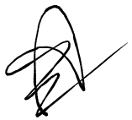Originality.”

Andre Hei Wang Law

4017 5600

01/04/2024

# **1) Objectives**

For the fourth experiment of the course Elec 372, students are tasked to investigate the transient and frequency response of control systems. For the transient response analysis, students aim to understand the behavior of open and closed loop systems under various conditions. For example, we will test with parameters such as rise time, peak time, overshoots and settling time. For the frequency response analysis, students will practice on observing response behavior under sinusoidal input signals of varying frequencies, observing changes in amplitude and phase. Overall, this experiment will provide practical insights to transient and frequency response.

# **2) Theory**

**Transient Response:**

-Study the behavior of open-loop and closed-loop systems using performance criteria such as rise time, peak time, overshoot, and settling time.

-Investigate the effect of changing proportional gain factor (𝐾𝑝) and introducing derivative feedback on system response.

-Analyze the impact of increasing 𝐾𝑝 on the damping ratio (ζ) and natural frequency (𝜔𝑛).

**Frequency Response:**

-Examine how systems respond to sinusoidal input signals of varying frequencies.

-Measure magnitude ratio and phase shift as functions of frequency.

-Use Bode plots and polar plots to visualize frequency response data.

-Conduct spot-frequency and sweep frequency measurements to assess system behavior across different frequency ranges.

# **3) Tasks / Results / Discussions**

## 3.1 Closed-Loop Transient Response

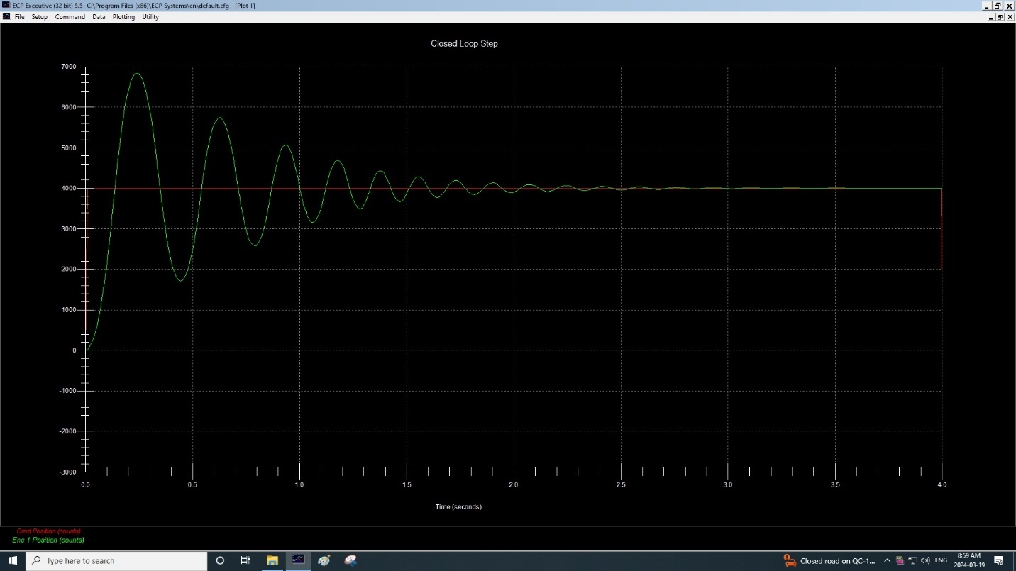Closed-Loop Step Response (Kp = 1)

Obtain* values for: the damped natural frequency πd and the overshoot (OS) and using a suitable axis scaling of the plot. (Kp = 1)

$$ω_{d}=\frac{π}{T_{p}} \\ Peak Time is around 0.25sec \\ ω_{d}=\frac{π}{T_{p}}=\frac{π}{0.25}=4π$$

$$PO=100\left[\frac{X_{1}-4000}{4000}\right]\% \\ X_{1} is around 6800 \\ PO=100\left[\frac{6800-4000}{4000}\right]\%=70\%$$

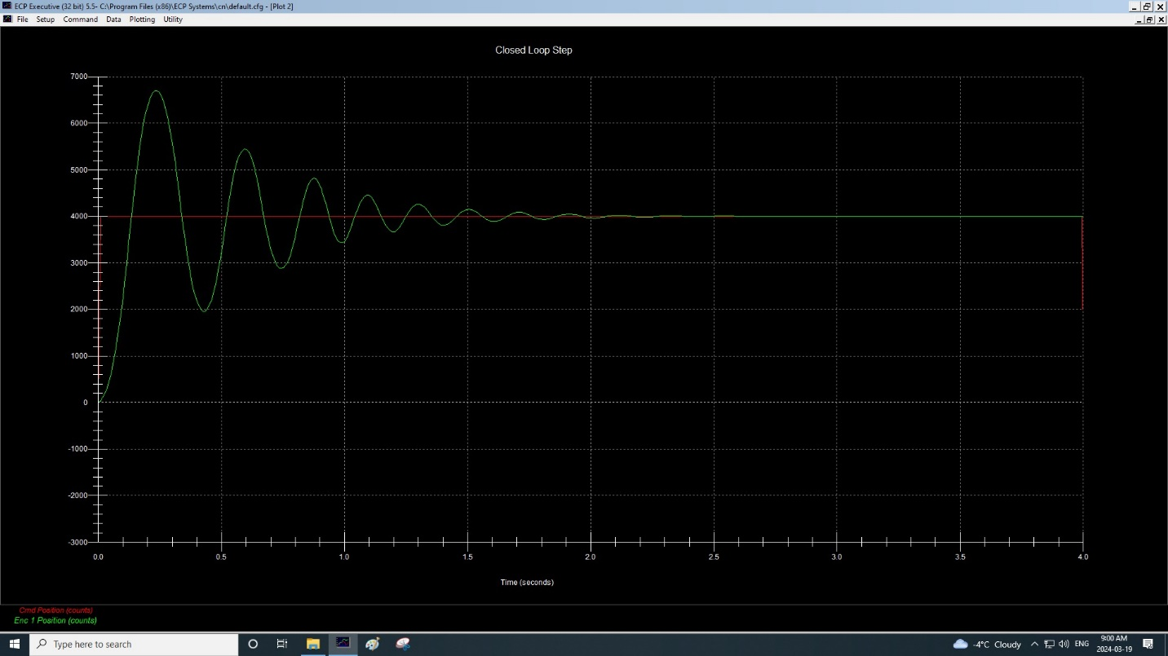Closed-Loop Step Response (Kp = 0.7)

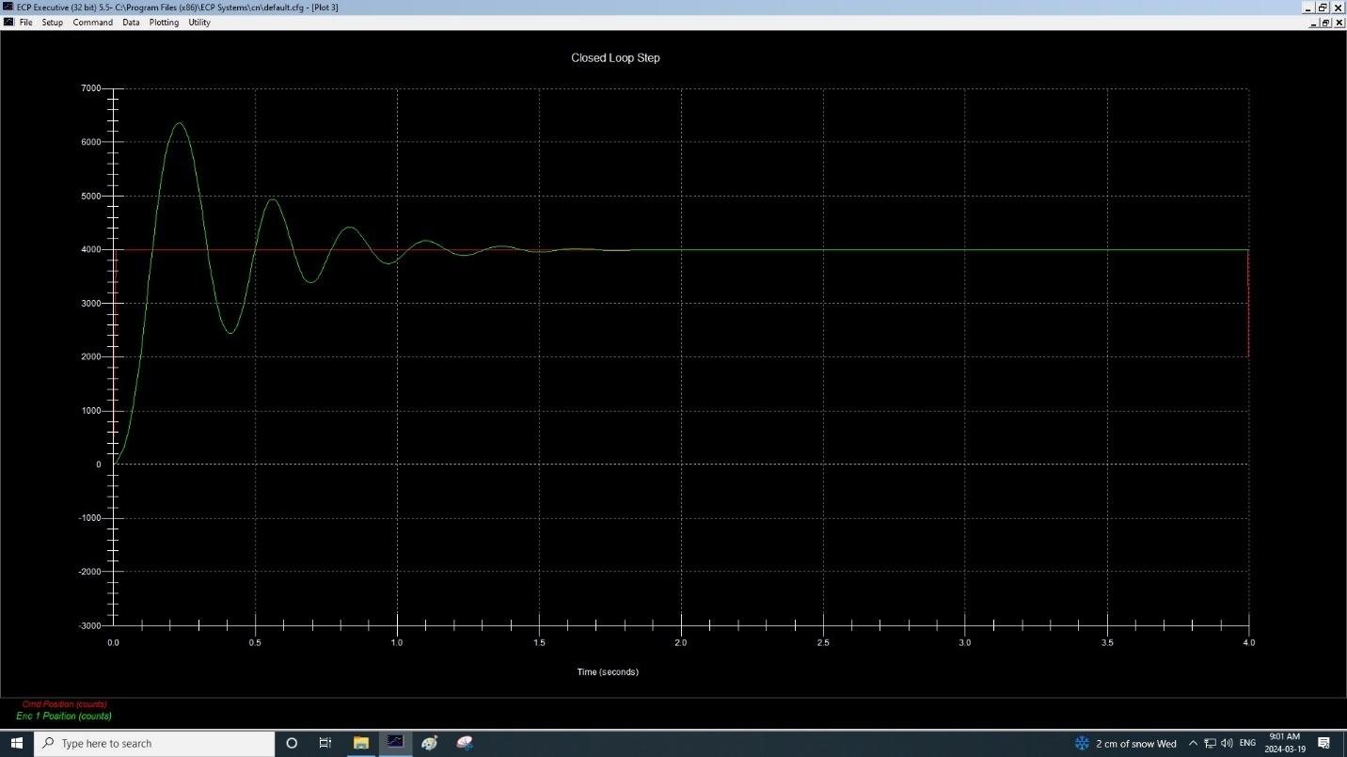Closed-Loop Step Response (Kp = 0.4)

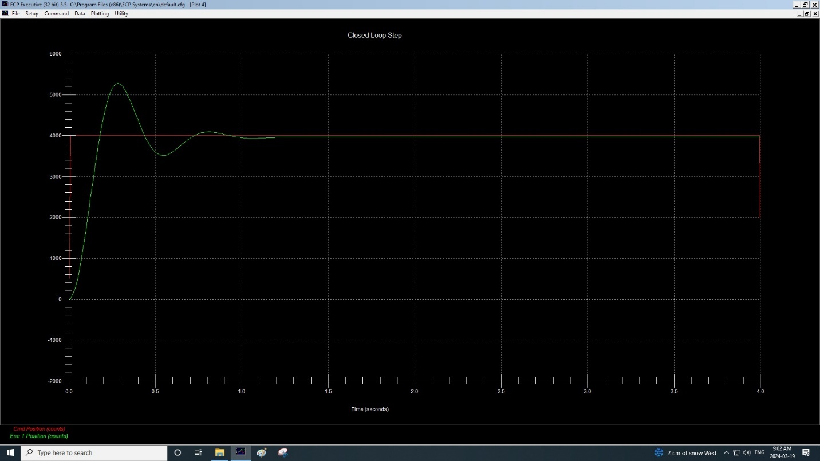Closed-Loop Step Response (Kp = 0.1)

### 3.1.1 Results

1) Tabulate ωd and OS values for the above cases.

|  |  |  |  |  |
| --- | --- | --- | --- | --- |
| Kp | Tp | X1 | ωd | PO |
| 1 | 0.25 | 6800 | 4π or 12.57 | 70% |
| 0.7 | 0.265 | 6600 | 11.86 | 65% |
| 0.4 | 0.28 | 6400 | 11.22 | 60% |
| 0.1 | 0.295 | 5300 | 10.65 | 32.5% |

2) Write a brief summary about the difference between open-loop and closed-loop system?

An open-loop systems functions without any feedback from the output. For a closed-loop system, we have feedback which is used to adjust subsequent inputs. As such, closed-loop systems can monitor and adapt to changes or stabilise itself to a certain margin.

3) From the OS values, use Equation (6.2) to calculate and tabulate the values of ζ, corresponding to the four Kp values used. Obtain a plot showing the effect of increasing Kp on the damping ratio ζ and comment on the result.

$$ζ=\sqrt{\frac{{\left(ln p\right)}^{2}}{{π^{2}\left(ln p\right)}^{2}}}$$

|  |  |  |
| --- | --- | --- |
| Kp | p | $$ζ$$ |
| 1 | 70% | 0.11 |
| 0.7 | 65% | 0.14 |
| 0.4 | 60% | 0.16 |
| 0.1 | 32.5% | 0.34 |

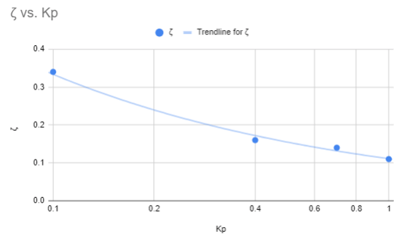

It can be noticed that by increasing Kp, the damping ratio decreases exponentially. For example, with an increase of Kp from 0.4, 0.7 and 1, the damping ratio decreases marginally from 0.16, 0.14 and 0.11 respectively. However, the jump from K­p of 0.1 to 0.4, notice that the damping ratio decrease largely from 0.34 to 0.16.

4) From the tabulated values of ζ and ωd, determine the corresponding ωn values. Obtain a plot showing the effect of increasing Kp on the natural frequency ωn and comment on the result.

$$ω_{n}=\frac{ω_{d}}{\sqrt{1-ζ^{2}}}$$

|  |  |  |  |
| --- | --- | --- | --- |
| Kp | ωd |  | ωn |
| 1 | 4π or 12.57 | 0.11 | 12.64 |
| 0.7 | 11.86 | 0.14 | 11.98 |
| 0.4 | 11.22 | 0.16 | 11.37 |
| 0.1 | 10.65 | 0.34 | 11.32 |

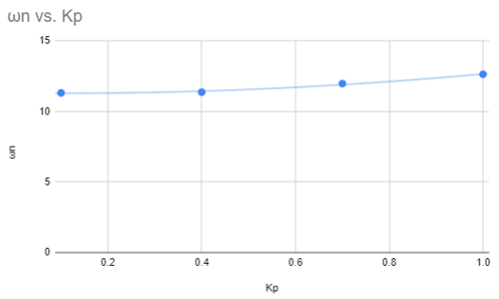

The natural frequency increases as Kp increases. The rate of increase in minimal as seen above.

### 3.1.2 Analysis in MATLAB

1) Use the following settings: Ts = 0.00442 sec, Kp = 0.1 Ki = 0 and Kd = 0.005 and the obtained model in Experiment #2, write MATLAB code to calculate CLTF in the configuration of “PI + velocity feedback”, see formula 6.3.

2) Refer to sample code in Experiment #1, using MATLAB LTI Viewer to analysis system step response.

(Raw MATLAB export found in the appendix)

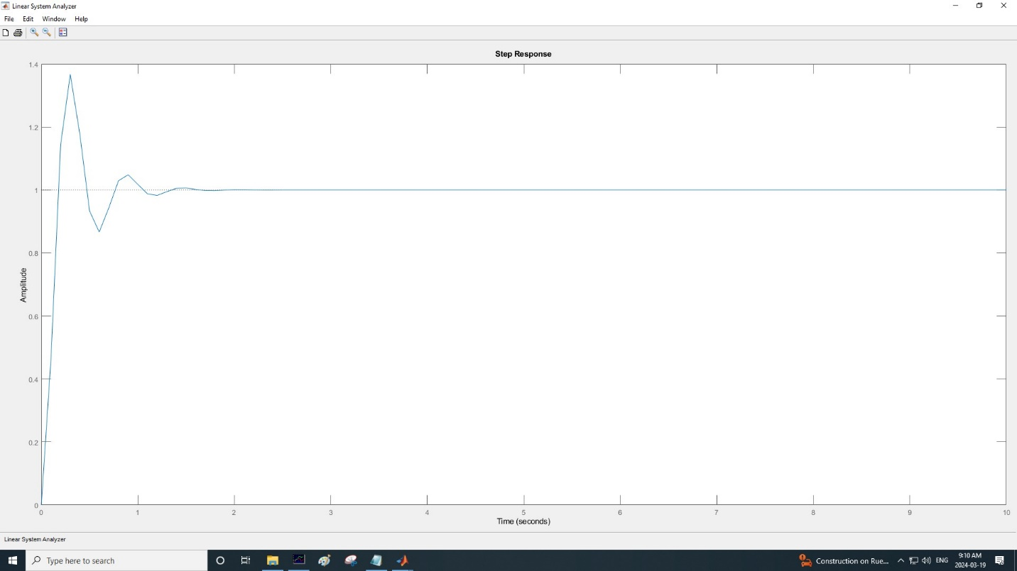Closed-Loop Step Response (Kp = 0.1)

3) Compare the result with the exported raw data, for at least one Kp.

For Kp = 0.1, the above MATLAB figure has more peaks when compared to the one tested using ECP. Here, there are three peaks while the ECP only has two. In addition, MATLAB’s curve is less smooth as seen from its pointy and sharp increases and decreases.

## 3.2 Open-Loop Frequency Response

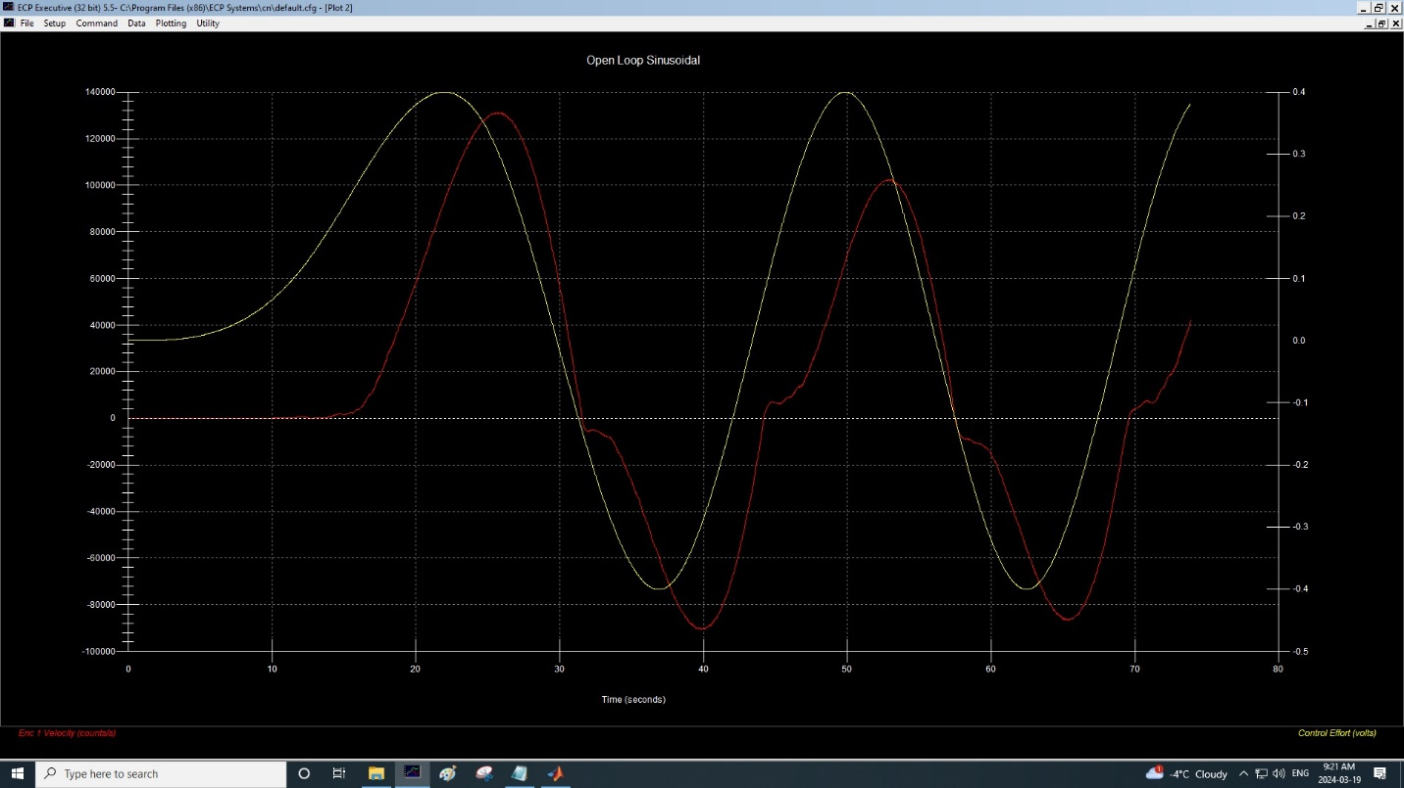Open-Loop Sinusoidal (f=0.04)

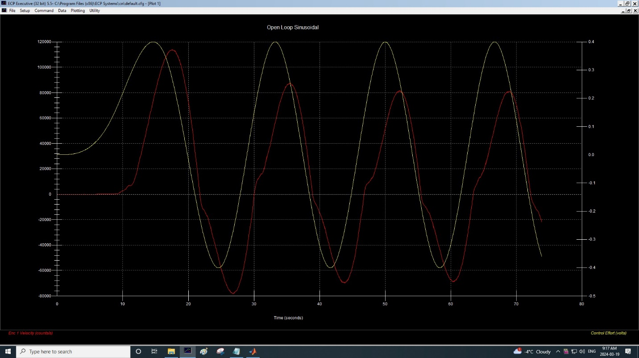Open-Loop Sinusoidal (f=0.06)

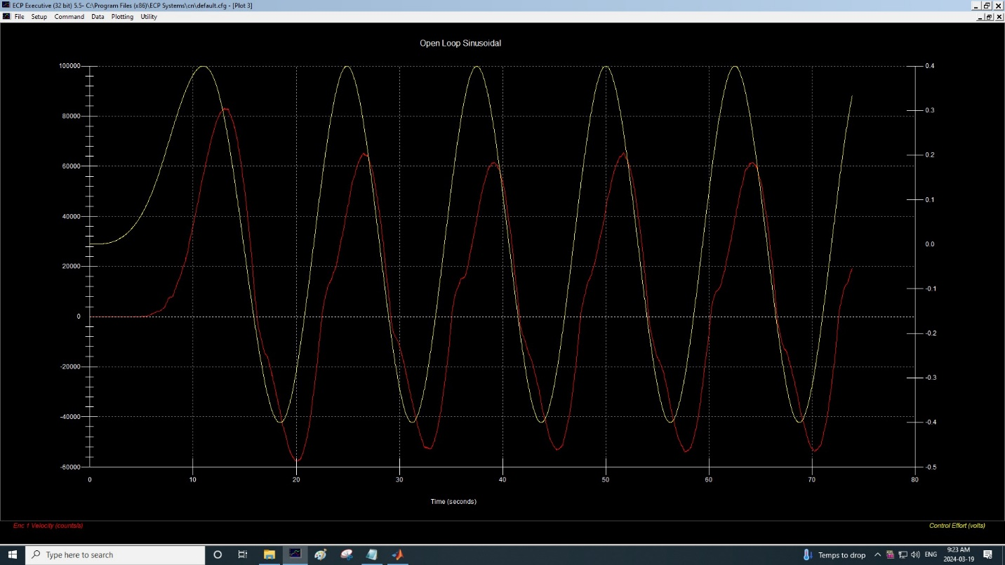Open-Loop Sinusoidal (f=0.08)

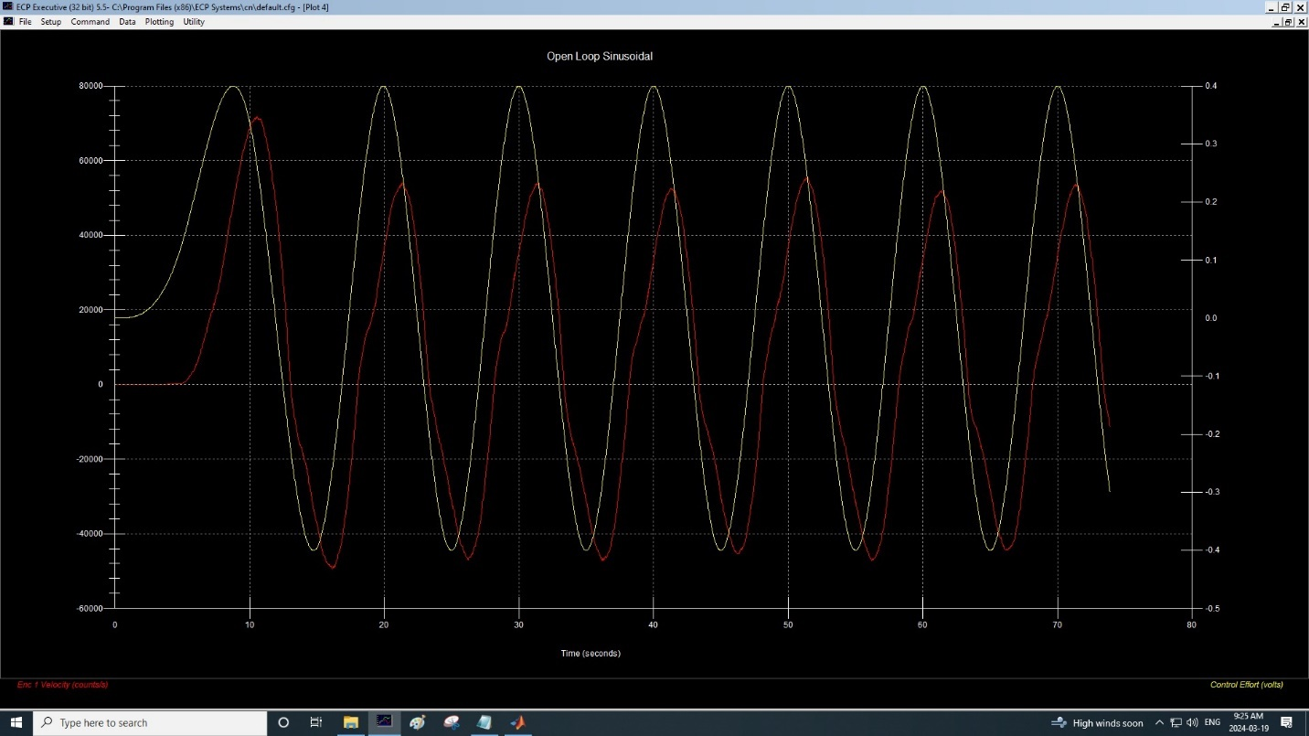Open-Loop Sinusoidal (f=0.1)

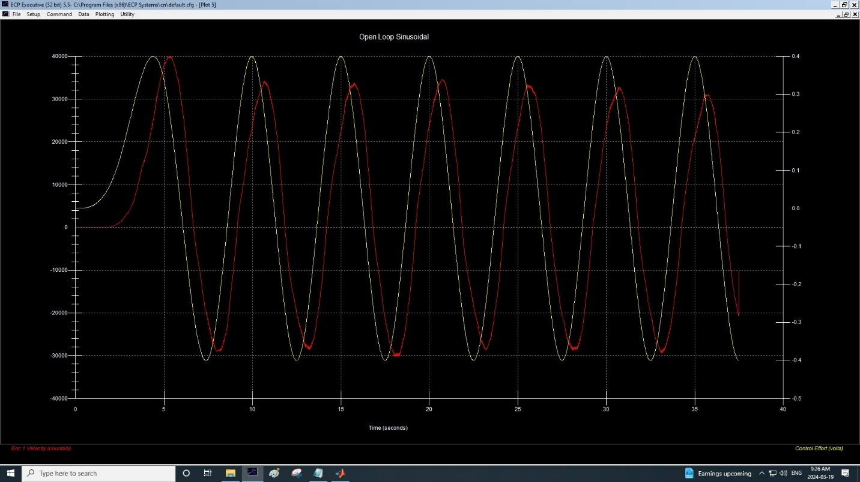Open-Loop Sinusoidal (f=0.2)

$$Phase Shift=-360*f*Tphase \\ w=2*pi*f$$

|  |  |  |  |  |
| --- | --- | --- | --- | --- |
| Frequency | w(rad/sec) | Ωpp | Tphase (sec) | Phase Shift |
| 0.04 | 0.25 | 190000 | 3.5 | -50.4 |
| 0.06 | 0.38 | 160000 | 2 | -43.2 |
| 0.08 | 0.50 | 145000 | 1.6 | -46.08 |
| 0.1 | 0.63 | 98000 | 1.2 | -43.2 |
| 0.2 | 1.26 | 70000 | 0.8 | -57.6 |

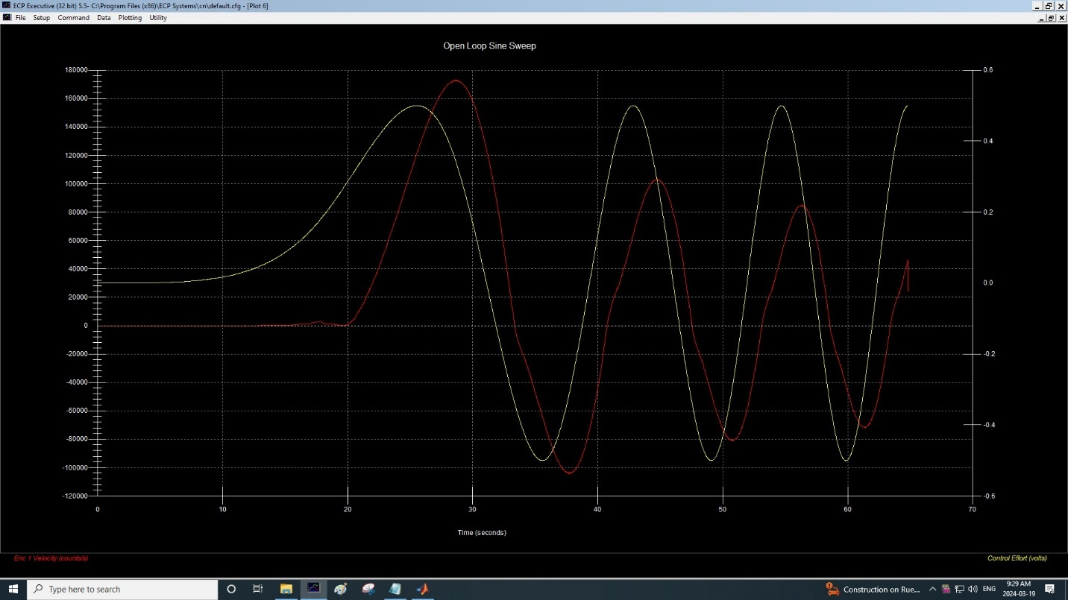Open-Loop Linear Sweep

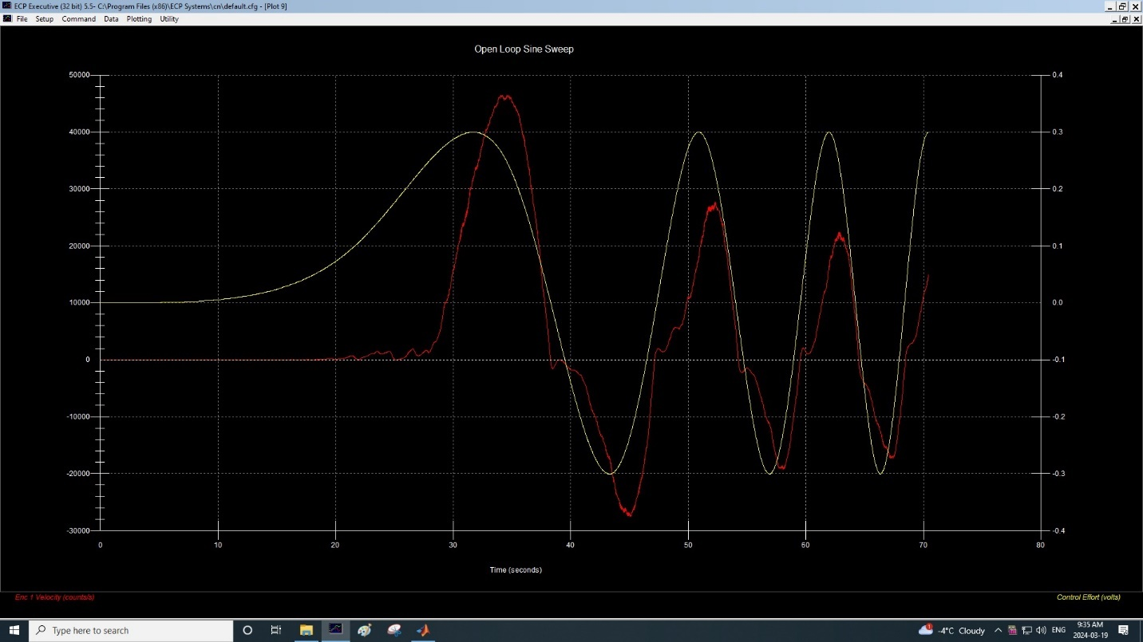Open-Loop Log Sweep

### 3.2.1 Results

1) Using the data tabulated in Step 4 above, use the conversion factor Ke to convert the values of Ωpp (counts/sec.) to Ωpp (radians/sec.). Plot Ωpp (radians/sec.) against the radian frequency ω using a linear scale.

Kp = 2546.5

Ωpp (rad/sec) = Ωpp (counts/sec)/Kp

|  |  |  |
| --- | --- | --- |
| w(rad/sec) | Ωpp (counts/sec) | Ωpp (rad/sec) |
| 0.25 | 190000 | 74.61 |
| 0.38 | 160000 | 62.83 |
| 0.50 | 145000 | 56.94 |
| 0.63 | 98000 | 38.48 |
| 1.26 | 70000 | 27.49 |

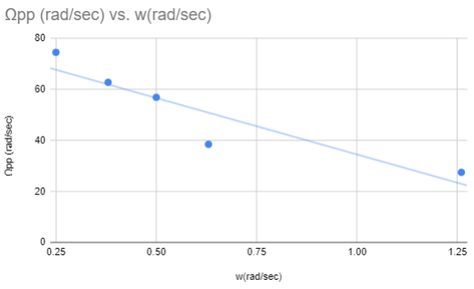

Ωpp (rad/sec) over w(rad/sec) with Linear Scale

2) Assuming that the input remained constant, the output magnitude should also be a constant (say, Y) at low frequencies approaching 0 Hz. Using the magnitude equation, it can be shown that the output magnitude will drop to (1/2)0.5Y or 0.707Y when ωc = 1/ τ, where ωc is called the ‘cut-off frequency’ or ‘break frequency’. Assuming Y is the magnitude corresponding to the frequency of 0.04 Hz, determine ωc and hence find τ. How does this value compare with the value found in EXPR#2(Sect4.3.2)? Comment on any difference observed. (The value of τ = 1/ωc can also be estimated by finding fc =1/2piωc where the phase shift is – 45o.)

Yes, these values are similar to the value found in experiment #2 section 4.3.2.

## 3.3 Closed-Loop Frequency Response

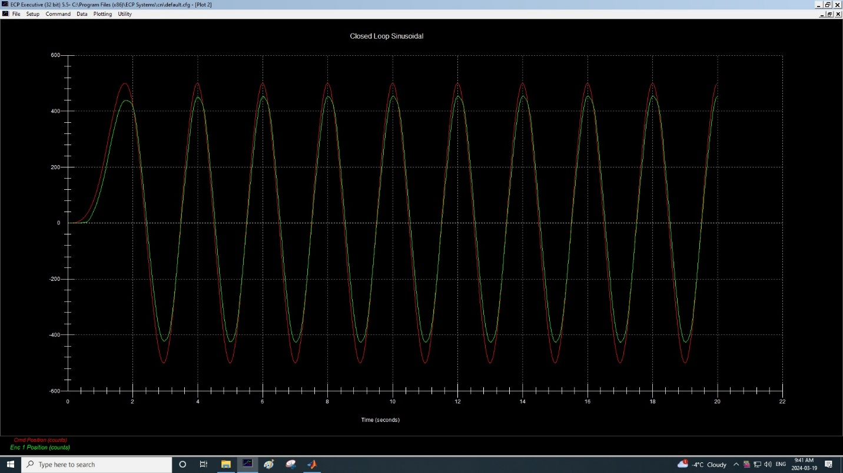Closed Loop Sinusoidal (f=0.5)

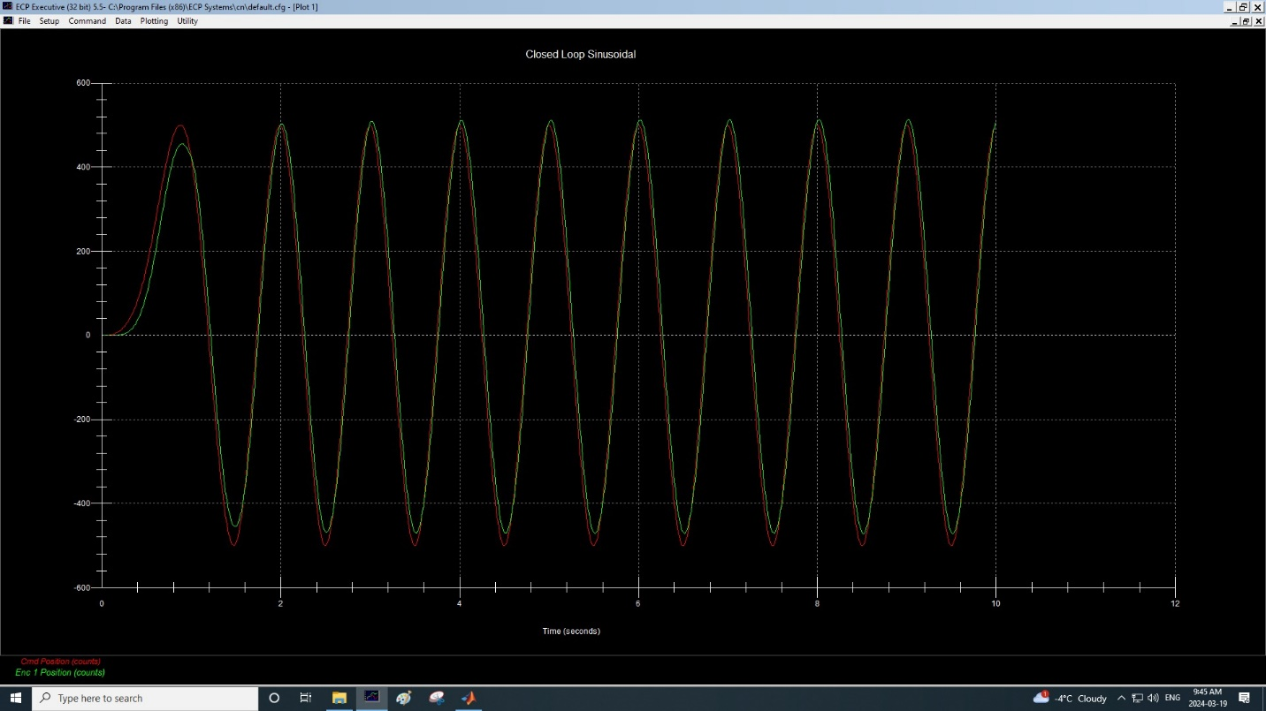Closed Loop Sinusoidal (f=1)

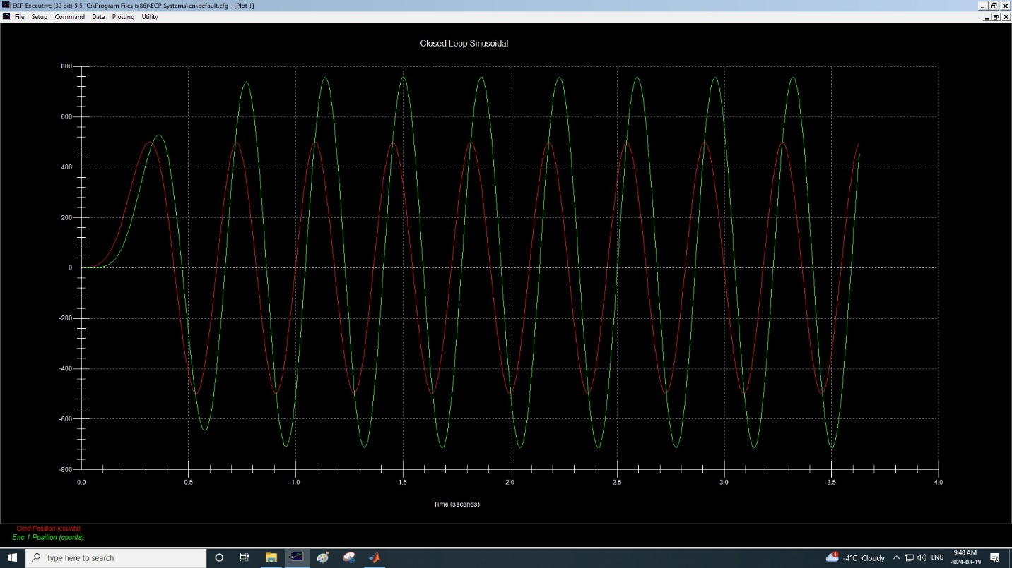Closed Loop Sinusoidal (f=2.75)

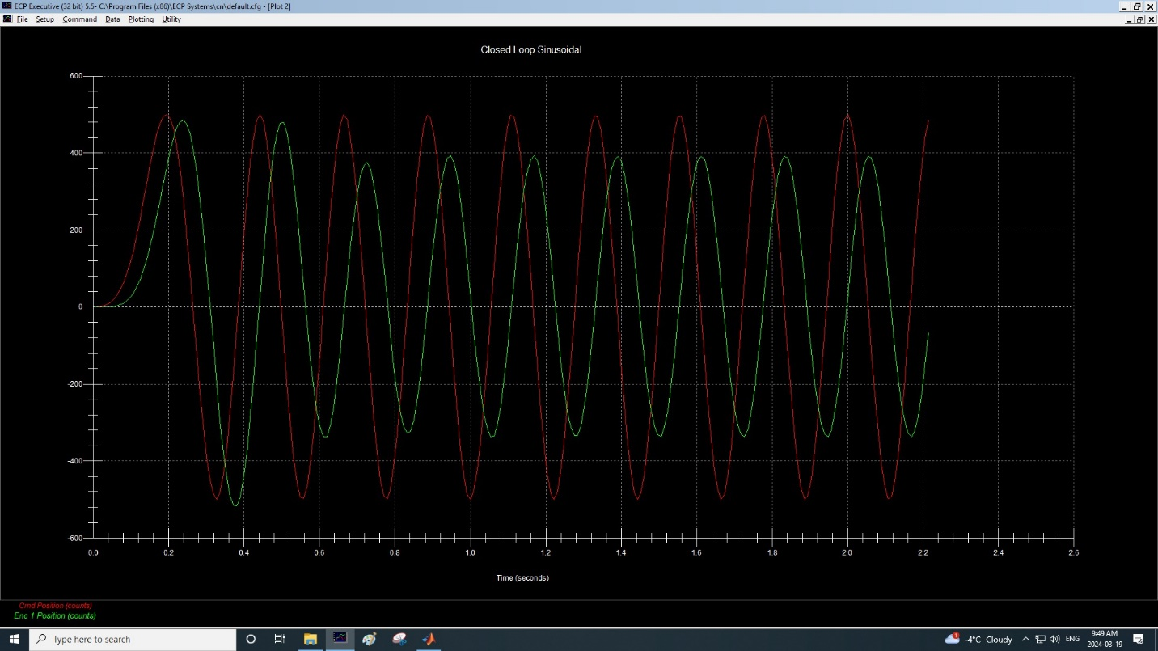Closed Loop Sinusoidal (f=4.5)

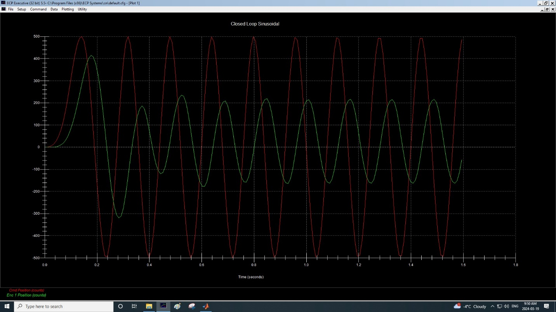Closed Loop Sinusoidal (f=6.25)

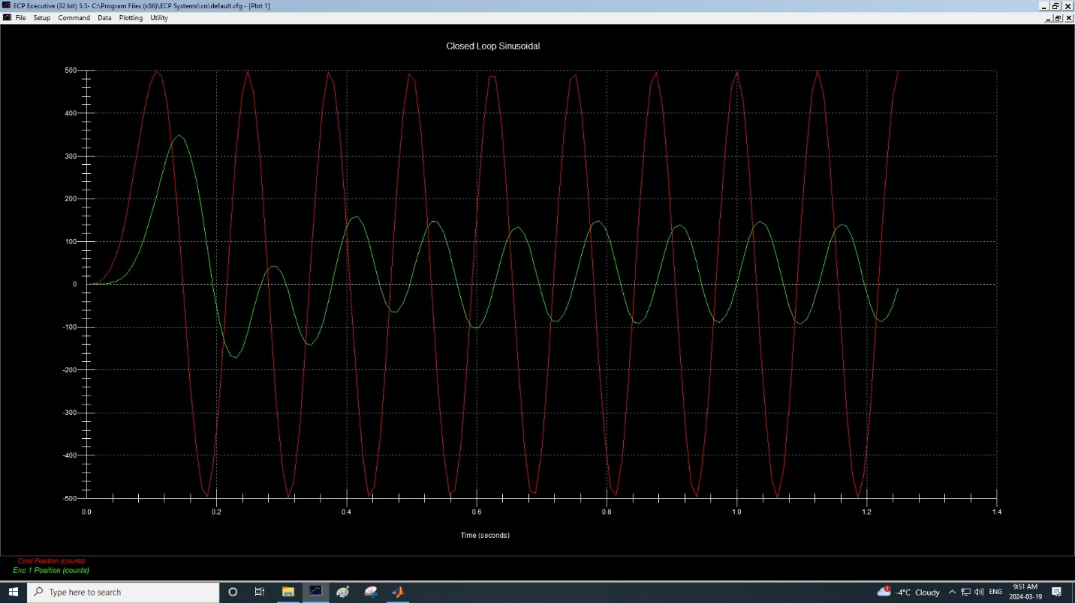Closed Loop Sinusoidal (f=8)

|  |  |  |
| --- | --- | --- |
| Frequency (Hz) | Peak-Peak Output (Counts) | Tphase(sec) |
| 0.5 | 410 | 0.04 |
| 1 | 510 | 0.03 |
| 2.75 | 700 | 0.05 |
| 4.5 | 380 | 0.3 |
| 6.25 | 190 | 0.048 |
| 8 | 100 | 0.04 |

### 3.3.1 Results: Spot-Frequency Measurement

1) Use the data table obtained in Step 3 to calculate and tabulate M(dB) and φ(degrees) against ω=2πf (radians/sec). Obtain Bode magnitude and phase plots for the frequency range 0.05 to 8 Hz (~0.3 to 50.3 radians/sec). Use 3-cycle semi-logarithmic graph paper. Also draw the corresponding polar plot for your data range.

$$M\left(dB\right)=20\log_{10}\left(M\right) \\ where M=Output/Input Amplitude \\ Imput Amplitude=500$$

|  |  |  |  |
| --- | --- | --- | --- |
| Frequency (Hz) | w(2*pi*f) | M(dB) | φ(degrees) |
| 0.5 | π | -1.72 | 7.2 |
| 1 | 2π | 0.17 | 10.8 |
| 2.75 | 5.5π | 2.92 | 49.5 |
| 4.5 | 9π | -2.38 | 486 |
| 6.25 | 12.5π | -8.4 | 108 |
| 8 | 16π | -13.98 | 115.2 |

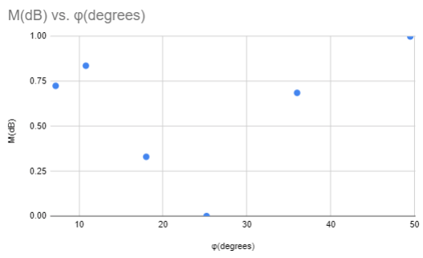

M(dB) vs Phase Shift (scaled)

2) Attempt to fit the Bode magnitude data to an asymptotic plot and hence obtain an approximate transfer function.

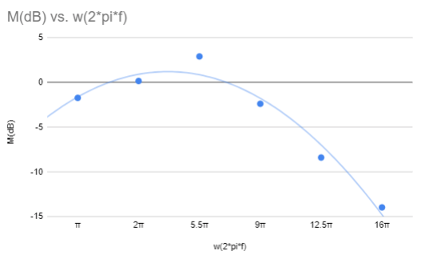

M(dB) vs Radian Frequency

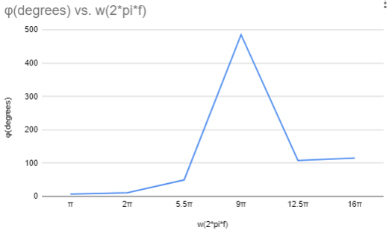

Phase Shift vs Radian Frequency

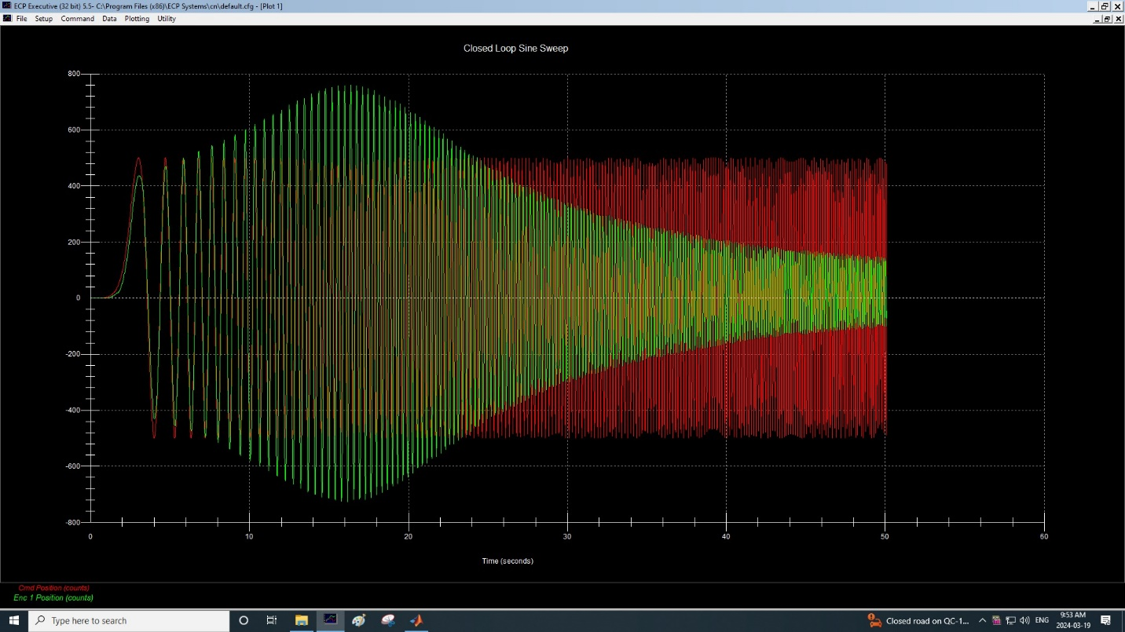

Closed Loop Linear Sine Sweep

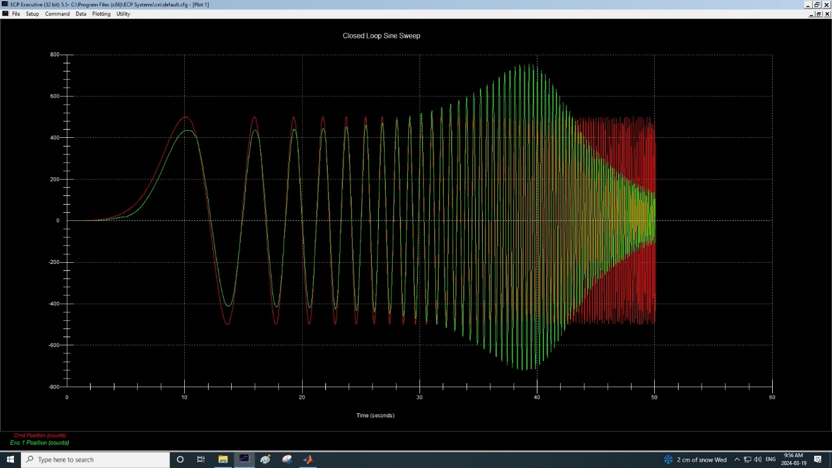

Closed Loop Log Sine Sweep

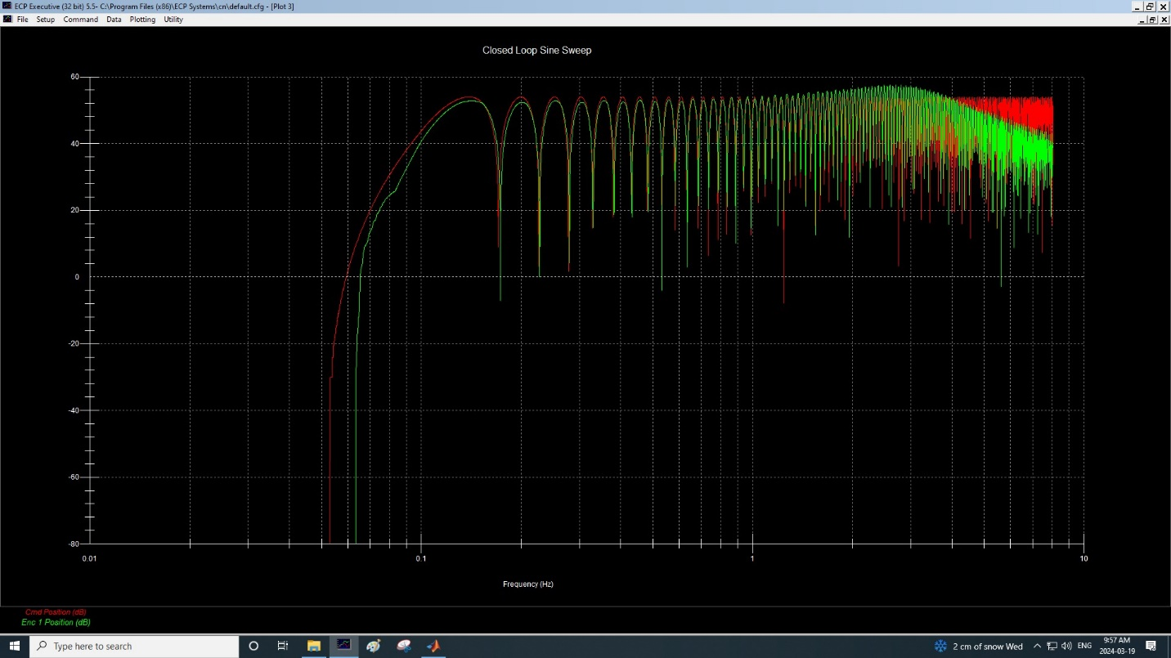

Closed Loop Log Sine Sweep with M in DB

### 3.3.2 Results: Sweep Frequency Measurement

1) Evaluate the amplitude and frequency and at a few points on the curve and compare the results with the spot-frequency data obtained earlier. Comment on the results.

|  |  |  |
| --- | --- | --- |
| Frequency (Hz) | Amplitude (Counts), Spot | Amplitude (Counts), Sweep |
| 0.5 | 410 | 420 |
| 1 | 510 | 500 |
| 2.75 | 700 | 720 |
| 4.5 | 380 | 370 |
| 6.25 | 190 | 220 |
| 8 | 100 | 130 |

While each individual amplitude values of the spot frequency data and the sweep frequency data are different, notice that the general trend remains the same. As we increase the frequency from 0.5Hz to 8Hz, notice how the amplitude increase until it peaks at frequency 2.75, then it reduces back down.

2) *Use MATLAB LTI viewer to do system frequency-domain analysis. Refer to the code in the section 6.3 CLOSED-LOOP TRANSIENT RESPONSE.

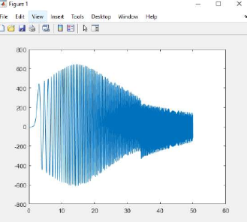

Closed Loop Transient Response MATLAB

3) Summarize the roles of engineering tool MATLAB/Simulink when you design a control system.

The role of the engineering tool MATLAB and Simulink when designing a control system is to provide a simulation environment to test and validate results. Given a correct set of instruction, it is able to predict theoretical values which is useful when trying to analyse the results. In our case, students used MATLAB to validate their experiments by exporting the raw data from the ECP 220. Overall, it is a very practical tool that can be used to facilitate control, system design as well as a simulation platform to verify experimental results.

# **4) Questions**

(answered throughout the whole report)

# **5) Conclusions**

In conclusion, the fourth experiment of Elec 372 provided practical insights into transient and frequency responses of control systems. By testing various input parameters such as rise time, overshoot and phase shift, students were able to analyse the behavior and stability of open and closed loop systems. For the second part, students practiced on frequency response on systems with different input frequencies such as magnitude and phase. Overall, this lab experiment contributed to the student’s knowledge on control systems and their transient and frequency response.

# **6) Appendix**

MATLAB file for 3.2.2 (Closed-Loop Step Response Kp = 0.1)

% Sample Time Commanded Pos Encoder 1 Pos Encoder 2 Pos   
  
data = [ 0 0.000 4000 0 0;  
 1 0.009 4000 18 0;  
 2 0.018 4000 80 3;  
 3 0.027 4000 170 18;  
 4 0.035 4000 276 45;  
 5 0.044 4000 402 84;  
 6 0.053 4000 557 128;  
 7 0.062 4000 747 175;  
 8 0.071 4000 961 226;  
 9 0.080 4000 1189 285;  
 10 0.089 4000 1428 348;  
 11 0.097 4000 1678 414;  
 12 0.106 4000 1937 481;  
 13 0.115 4000 2202 548;  
 14 0.124 4000 2468 616;  
 15 0.133 4000 2733 684;  
 16 0.142 4000 2994 750;  
 17 0.151 4000 3250 815;  
 18 0.159 4000 3495 879;  
 19 0.168 4000 3728 940;  
 20 0.177 4000 3951 996;  
 21 0.186 4000 4162 1048;  
 22 0.195 4000 4360 1096;  
 23 0.204 4000 4538 1141;  
 24 0.213 4000 4696 1183;  
 25 0.221 4000 4835 1219;  
 26 0.230 4000 4957 1251;  
 27 0.239 4000 5060 1276;  
 28 0.248 4000 5143 1296;  
 29 0.257 4000 5204 1311;  
 30 0.266 4000 5247 1322;  
 31 0.274 4000 5270 1327;  
 32 0.283 4000 5277 1328;  
 33 0.292 4000 5267 1327;  
 34 0.301 4000 5241 1320;  
 35 0.310 4000 5201 1310;  
 36 0.319 4000 5149 1296;  
 37 0.328 4000 5086 1280;  
 38 0.336 4000 5015 1262;  
 39 0.345 4000 4936 1241;  
 40 0.354 4000 4851 1220;  
 41 0.363 4000 4761 1197;  
 42 0.372 4000 4669 1173;  
 43 0.381 4000 4575 1149;  
 44 0.390 4000 4480 1125;  
 45 0.398 4000 4386 1100;  
 46 0.407 4000 4293 1077;  
 47 0.416 4000 4202 1053;  
 48 0.425 4000 4115 1031;  
 49 0.434 4000 4031 1009;  
 50 0.443 4000 3953 989;  
 51 0.452 4000 3879 971;  
 52 0.460 4000 3812 953;  
 53 0.469 4000 3750 938;  
 54 0.478 4000 3696 924;  
 55 0.487 4000 3649 912;  
 56 0.496 4000 3609 902;  
 57 0.505 4000 3576 894;  
 58 0.514 4000 3550 887;  
 59 0.522 4000 3531 882;  
 60 0.531 4000 3519 879;  
 61 0.540 4000 3513 878;  
 62 0.549 4000 3511 877;  
 63 0.558 4000 3516 877;  
 64 0.567 4000 3527 880;  
 65 0.576 4000 3542 884;  
 66 0.584 4000 3561 889;  
 67 0.593 4000 3583 895;  
 68 0.602 4000 3608 901;  
 69 0.611 4000 3636 908;  
 70 0.620 4000 3665 915;  
 71 0.629 4000 3695 923;  
 72 0.638 4000 3726 931;  
 73 0.646 4000 3758 939;  
 74 0.655 4000 3789 947;  
 75 0.664 4000 3820 955;  
 76 0.673 4000 3850 963;  
 77 0.682 4000 3879 970;  
 78 0.691 4000 3907 977;  
 79 0.699 4000 3934 984;  
 80 0.708 4000 3958 990;  
 81 0.717 4000 3981 996;  
 82 0.726 4000 4002 1001;  
 83 0.735 4000 4021 1006;  
 84 0.744 4000 4038 1010;  
 85 0.753 4000 4052 1014;  
 86 0.761 4000 4064 1017;  
 87 0.770 4000 4074 1019;  
 88 0.779 4000 4082 1021;  
 89 0.788 4000 4087 1023;  
 90 0.797 4000 4091 1024;  
 91 0.806 4000 4092 1024;  
 92 0.815 4000 4092 1024;  
 93 0.823 4000 4091 1024;  
 94 0.832 4000 4087 1024;  
 95 0.841 4000 4082 1023;  
 96 0.850 4000 4076 1021;  
 97 0.859 4000 4069 1020;  
 98 0.868 4000 4061 1017;  
 99 0.877 4000 4053 1015;  
 100 0.885 4000 4044 1013;  
 101 0.894 4000 4036 1011;  
 102 0.903 4000 4027 1009;  
 103 0.912 4000 4018 1006;  
 104 0.921 4000 4009 1004;  
 105 0.930 4000 4000 1002;  
 106 0.939 4000 3992 1000;  
 107 0.947 4000 3984 998;  
 108 0.956 4000 3976 996;  
 109 0.965 4000 3969 994;  
 110 0.974 4000 3963 992;  
 111 0.983 4000 3957 991;  
 112 0.992 4000 3951 989;  
 113 1.001 4000 3947 988;  
 114 1.009 4000 3943 987;  
 115 1.018 4000 3940 987;  
 116 1.027 4000 3937 986;  
 117 1.036 4000 3935 985;  
 118 1.045 4000 3934 985;  
 119 1.054 4000 3934 985;  
 120 1.063 4000 3933 985;  
 121 1.071 4000 3933 985;  
 122 1.080 4000 3935 985;  
 123 1.089 4000 3935 985;  
 124 1.098 4000 3937 985;  
 125 1.107 4000 3939 985;  
 126 1.116 4000 3941 985;  
 127 1.124 4000 3943 985;  
 128 1.133 4000 3945 987;  
 129 1.142 4000 3947 987;  
 130 1.151 4000 3949 987;  
 131 1.160 4000 3951 988;  
 132 1.169 4000 3952 988;  
 133 1.178 4000 3954 989;  
 134 1.186 4000 3955 989;  
 135 1.195 4000 3957 989;  
 136 1.204 4000 3958 990;  
 137 1.213 4000 3959 990;  
 138 1.222 4000 3959 990;  
 139 1.231 4000 3960 990;  
 140 1.240 4000 3960 991;  
 141 1.248 4000 3961 991;  
 142 1.257 4000 3961 991;  
 143 1.266 4000 3961 991;  
 144 1.275 4000 3961 991;  
 145 1.284 4000 3961 991;  
 146 1.293 4000 3961 991;  
 147 1.302 4000 3961 991;  
 148 1.310 4000 3961 991;  
 149 1.319 4000 3961 991;  
 150 1.328 4000 3961 991;  
 151 1.337 4000 3961 991;  
 152 1.346 4000 3961 991;  
 153 1.355 4000 3961 991;  
 154 1.364 4000 3961 991;  
 155 1.372 4000 3961 991;  
 156 1.381 4000 3961 991;  
 157 1.390 4000 3961 991;  
 158 1.399 4000 3961 991;  
 159 1.408 4000 3961 991;  
 160 1.417 4000 3961 991;  
 161 1.426 4000 3961 991;  
 162 1.434 4000 3961 991;  
 163 1.443 4000 3961 991;  
 164 1.452 4000 3961 991;  
 165 1.461 4000 3961 991;  
 166 1.470 4000 3961 991;  
 167 1.479 4000 3961 991;  
 168 1.488 4000 3961 991;  
 169 1.496 4000 3961 991;  
 170 1.505 4000 3961 991;  
 171 1.514 4000 3961 991;  
 172 1.523 4000 3961 991;  
 173 1.532 4000 3961 991;  
 174 1.541 4000 3961 991;  
 175 1.549 4000 3961 991;  
 176 1.558 4000 3961 991;  
 177 1.567 4000 3961 991;  
 178 1.576 4000 3961 991;  
 179 1.585 4000 3961 991;  
 180 1.594 4000 3961 991;  
 181 1.603 4000 3961 991;  
 182 1.611 4000 3961 991;  
 183 1.620 4000 3961 991;  
 184 1.629 4000 3961 991;  
 185 1.638 4000 3961 991;  
 186 1.647 4000 3961 991;  
 187 1.656 4000 3961 991;  
 188 1.665 4000 3961 991;  
 189 1.673 4000 3961 991;  
 190 1.682 4000 3961 991;  
 191 1.691 4000 3961 991;  
 192 1.700 4000 3961 991;  
 193 1.709 4000 3961 991;  
 194 1.718 4000 3961 991;  
 195 1.727 4000 3961 991;  
 196 1.735 4000 3961 991;  
 197 1.744 4000 3961 991;  
 198 1.753 4000 3961 991;  
 199 1.762 4000 3961 991;  
 200 1.771 4000 3961 991;  
 201 1.780 4000 3961 991;  
 202 1.789 4000 3961 991;  
 203 1.797 4000 3961 991;  
 204 1.806 4000 3961 991;  
 205 1.815 4000 3961 991;  
 206 1.824 4000 3961 991;  
 207 1.833 4000 3961 991;  
 208 1.842 4000 3961 991;  
 209 1.851 4000 3961 991;  
 210 1.859 4000 3961 991;  
 211 1.868 4000 3961 991;  
 212 1.877 4000 3961 991;  
 213 1.886 4000 3961 991;  
 214 1.895 4000 3961 991;  
 215 1.904 4000 3961 991;  
 216 1.913 4000 3961 991;  
 217 1.921 4000 3961 991;  
 218 1.930 4000 3961 991;  
 219 1.939 4000 3961 991;  
 220 1.948 4000 3961 991;  
 221 1.957 4000 3961 991;  
 222 1.966 4000 3961 991;  
 223 1.974 4000 3961 991;  
 224 1.983 4000 3961 991;  
 225 1.992 4000 3961 991;  
 226 2.001 4000 3961 991;  
 227 2.010 4000 3961 991;  
 228 2.019 4000 3961 991;  
 229 2.028 4000 3961 991;  
 230 2.036 4000 3961 991;  
 231 2.045 4000 3961 991;  
 232 2.054 4000 3961 991;  
 233 2.063 4000 3961 991;  
 234 2.072 4000 3961 991;  
 235 2.081 4000 3961 991;  
 236 2.090 4000 3961 991;  
 237 2.098 4000 3961 991;  
 238 2.107 4000 3961 991;  
 239 2.116 4000 3961 991;  
 240 2.125 4000 3961 991;  
 241 2.134 4000 3961 991;  
 242 2.143 4000 3961 991;  
 243 2.152 4000 3961 991;  
 244 2.160 4000 3961 991;  
 245 2.169 4000 3961 991;  
 246 2.178 4000 3961 991;  
 247 2.187 4000 3961 991;  
 248 2.196 4000 3961 991;  
 249 2.205 4000 3961 991;  
 250 2.214 4000 3961 991;  
 251 2.222 4000 3961 991;  
 252 2.231 4000 3961 991;  
 253 2.240 4000 3961 991;  
 254 2.249 4000 3961 991;  
 255 2.258 4000 3961 991;  
 256 2.267 4000 3961 991;  
 257 2.276 4000 3961 991;  
 258 2.284 4000 3961 991;  
 259 2.293 4000 3961 991;  
 260 2.302 4000 3961 991;  
 261 2.311 4000 3961 991;  
 262 2.320 4000 3961 991;  
 263 2.329 4000 3961 991;  
 264 2.338 4000 3961 991;

265 2.346 4000 3961 991;  
 266 2.355 4000 3961 991;  
 267 2.364 4000 3961 991;  
 268 2.373 4000 3961 991;  
 269 2.382 4000 3961 991;  
 270 2.391 4000 3961 991;  
 271 2.399 4000 3961 991;  
 272 2.408 4000 3961 991;  
 273 2.417 4000 3961 991;  
 274 2.426 4000 3961 991;  
 275 2.435 4000 3961 991;  
 276 2.444 4000 3961 991;  
 277 2.453 4000 3961 991;  
 278 2.461 4000 3961 991;  
 279 2.470 4000 3961 991;  
 280 2.479 4000 3961 991;  
 281 2.488 4000 3961 991;  
 282 2.497 4000 3961 991;  
 283 2.506 4000 3961 991;  
 284 2.515 4000 3961 991;  
 285 2.523 4000 3961 991;  
 286 2.532 4000 3961 991;  
 287 2.541 4000 3961 991;  
 288 2.550 4000 3961 991;  
 289 2.559 4000 3961 991;  
 290 2.568 4000 3961 991;  
 291 2.577 4000 3961 991;  
 292 2.585 4000 3961 991;  
 293 2.594 4000 3961 991;  
 294 2.603 4000 3961 991;  
 295 2.612 4000 3961 991;  
 296 2.621 4000 3961 991;  
 297 2.630 4000 3961 991;  
 298 2.639 4000 3961 991;  
 299 2.647 4000 3961 991;  
 300 2.656 4000 3961 991;  
 301 2.665 4000 3961 991;  
 302 2.674 4000 3961 991;  
 303 2.683 4000 3961 991;  
 304 2.692 4000 3961 991;  
 305 2.701 4000 3961 991;  
 306 2.709 4000 3961 991;  
 307 2.718 4000 3961 991;  
 308 2.727 4000 3961 991;  
 309 2.736 4000 3961 991;  
 310 2.745 4000 3961 991;  
 311 2.754 4000 3961 991;  
 312 2.763 4000 3961 991;  
 313 2.771 4000 3961 991;  
 314 2.780 4000 3961 991;  
 315 2.789 4000 3961 991;  
 316 2.798 4000 3961 991;  
 317 2.807 4000 3961 991;  
 318 2.816 4000 3961 991;  
 319 2.824 4000 3961 991;  
 320 2.833 4000 3961 991;  
 321 2.842 4000 3961 991;  
 322 2.851 4000 3961 991;  
 323 2.860 4000 3961 991;  
 324 2.869 4000 3961 991;  
 325 2.878 4000 3961 991;  
 326 2.886 4000 3961 991;  
 327 2.895 4000 3961 991;  
 328 2.904 4000 3961 991;  
 329 2.913 4000 3961 991;  
 330 2.922 4000 3961 991;  
 331 2.931 4000 3961 991;  
 332 2.940 4000 3961 991;  
 333 2.948 4000 3961 991;  
 334 2.957 4000 3961 991;  
 335 2.966 4000 3961 991;  
 336 2.975 4000 3961 991;  
 337 2.984 4000 3961 991;  
 338 2.993 4000 3961 991;  
 339 3.002 4000 3961 991;  
 340 3.010 4000 3961 991;  
 341 3.019 4000 3961 991;  
 342 3.028 4000 3961 991;  
 343 3.037 4000 3961 991;  
 344 3.046 4000 3961 991;  
 345 3.055 4000 3961 991;  
 346 3.064 4000 3961 991;  
 347 3.072 4000 3961 991;  
 348 3.081 4000 3961 991;  
 349 3.090 4000 3961 991;  
 350 3.099 4000 3961 991;  
 351 3.108 4000 3961 991;  
 352 3.117 4000 3961 991;  
 353 3.126 4000 3961 991;  
 354 3.134 4000 3961 991;  
 355 3.143 4000 3961 991;  
 356 3.152 4000 3961 991;  
 357 3.161 4000 3961 991;  
 358 3.170 4000 3961 991;  
 359 3.179 4000 3961 991;  
 360 3.188 4000 3961 991;  
 361 3.196 4000 3961 991;  
 362 3.205 4000 3961 991;  
 363 3.214 4000 3961 991;  
 364 3.223 4000 3961 991;  
 365 3.232 4000 3961 991;  
 366 3.241 4000 3961 991;  
 367 3.249 4000 3961 991;  
 368 3.258 4000 3961 991;  
 369 3.267 4000 3961 991;  
 370 3.276 4000 3961 991;  
 371 3.285 4000 3961 991;  
 372 3.294 4000 3961 991;  
 373 3.303 4000 3961 991;  
 374 3.311 4000 3961 991;  
 375 3.320 4000 3961 991;  
 376 3.329 4000 3961 991;  
 377 3.338 4000 3961 991;  
 378 3.347 4000 3961 991;  
 379 3.356 4000 3961 991;  
 380 3.365 4000 3961 991;  
 381 3.373 4000 3961 991;  
 382 3.382 4000 3961 991;  
 383 3.391 4000 3961 991;  
 384 3.400 4000 3961 991;  
 385 3.409 4000 3961 991;  
 386 3.418 4000 3961 991;  
 387 3.427 4000 3961 991;  
 388 3.435 4000 3961 991;  
 389 3.444 4000 3961 991;  
 390 3.453 4000 3961 991;  
 391 3.462 4000 3961 991;  
 392 3.471 4000 3961 991;  
 393 3.480 4000 3961 991;  
 394 3.489 4000 3961 991;  
 395 3.497 4000 3961 991;  
 396 3.506 4000 3961 991;  
 397 3.515 4000 3961 991;  
 398 3.524 4000 3961 991;  
 399 3.533 4000 3961 991;  
 400 3.542 4000 3961 991;  
 401 3.551 4000 3961 991;  
 402 3.559 4000 3961 991;  
 403 3.568 4000 3961 991;  
 404 3.577 4000 3961 991;  
 405 3.586 4000 3961 991;  
 406 3.595 4000 3961 991;  
 407 3.604 4000 3961 991;  
 408 3.613 4000 3961 991;  
 409 3.621 4000 3961 991;  
 410 3.630 4000 3961 991;  
 411 3.639 4000 3961 991;  
 412 3.648 4000 3961 991;  
 413 3.657 4000 3961 991;  
 414 3.666 4000 3961 991;  
 415 3.674 4000 3961 991;  
 416 3.683 4000 3961 991;  
 417 3.692 4000 3961 991;  
 418 3.701 4000 3961 991;  
 419 3.710 4000 3961 991;  
 420 3.719 4000 3961 991;  
 421 3.728 4000 3961 991;  
 422 3.736 4000 3961 991;  
 423 3.745 4000 3961 991;  
 424 3.754 4000 3961 991;  
 425 3.763 4000 3961 991;  
 426 3.772 4000 3961 991;  
 427 3.781 4000 3961 991;  
 428 3.790 4000 3961 991;  
 429 3.798 4000 3961 991;  
 430 3.807 4000 3961 991;  
 431 3.816 4000 3961 991;  
 432 3.825 4000 3961 991;  
 433 3.834 4000 3961 991;  
 434 3.843 4000 3961 991;  
 435 3.852 4000 3961 991;  
 436 3.860 4000 3961 991;  
 437 3.869 4000 3961 991;  
 438 3.878 4000 3961 991;  
 439 3.887 4000 3961 991;  
 440 3.896 4000 3961 991;  
 441 3.905 4000 3961 991;  
 442 3.914 4000 3961 991;  
 443 3.922 4000 3961 991;  
 444 3.931 4000 3961 991;  
 445 3.940 4000 3961 991;  
 446 3.949 4000 3961 991;  
 447 3.958 4000 3961 991;  
 448 3.967 4000 3961 991;  
 449 3.976 4000 3961 991;  
 450 3.984 4000 3961 991;  
 451 3.993 4000 3961 991;  
 452 4.002 0 3961 991;  
 453 4.011 0 3944 991;  
 454 4.020 0 3878 986;  
 455 4.029 0 3787 968;  
 456 4.038 0 3672 937;  
 457 4.046 0 3528 896;  
 458 4.055 0 3349 851;  
 459 4.064 0 3144 800;  
 460 4.073 0 2927 743;  
 461 4.082 0 2696 683;  
 462 4.091 0 2447 620;  
 463 4.099 0 2188 554;  
 464 4.108 0 1924 487;  
 465 4.117 0 1657 417;  
 466 4.126 0 1390 348;  
 467 4.135 0 1126 279;  
 468 4.144 0 865 211;  
 469 4.153 0 610 146;  
 470 4.161 0 361 84;  
 471 4.170 0 123 25;  
 472 4.179 0 -100 -32;  
 473 4.188 0 -304 -85;  
 474 4.197 0 -491 -135;  
 475 4.206 0 -662 -179;  
 476 4.215 0 -817 -216;  
 477 4.223 0 -954 -249;  
 478 4.232 0 -1071 -278;  
 479 4.241 0 -1168 -303;  
 480 4.250 0 -1245 -323;  
 481 4.259 0 -1303 -339;  
 482 4.268 0 -1342 -349;  
 483 4.277 0 -1364 -354;  
 484 4.285 0 -1370 -355;  
 485 4.294 0 -1358 -353;  
 486 4.303 0 -1330 -345;  
 487 4.312 0 -1288 -334;  
 488 4.321 0 -1236 -320;  
 489 4.330 0 -1172 -303;  
 490 4.339 0 -1100 -284;  
 491 4.347 0 -1021 -264;  
 492 4.356 0 -935 -242;  
 493 4.365 0 -845 -219;  
 494 4.374 0 -752 -195;  
 495 4.383 0 -657 -170;  
 496 4.392 0 -560 -145;  
 497 4.401 0 -464 -120;  
 498 4.409 0 -368 -95;  
 499 4.418 0 -274 -71;  
 500 4.427 0 -183 -48;  
 501 4.436 0 -96 -25;  
 502 4.445 0 -13 -4;  
 503 4.454 0 65 16;  
 504 4.463 0 137 34;  
 505 4.471 0 203 51;  
 506 4.480 0 262 66;  
 507 4.489 0 314 79;  
 508 4.498 0 360 91;  
 509 4.507 0 399 101;  
 510 4.516 0 430 109;  
 511 4.524 0 455 115;  
 512 4.533 0 473 120;  
 513 4.542 0 485 123;  
 514 4.551 0 490 124;  
 515 4.560 0 491 125;  
 516 4.569 0 484 125;  
 517 4.578 0 473 121;  
 518 4.586 0 458 117;  
 519 4.595 0 438 112;  
 520 4.604 0 415 106;  
 521 4.613 0 390 100;  
 522 4.622 0 362 93;  
 523 4.631 0 332 85;  
 524 4.640 0 301 77;  
 525 4.648 0 269 69;  
 526 4.657 0 237 60;  
 527 4.666 0 204 52;  
 528 4.675 0 172 44;  
 529 4.684 0 140 36;  
 530 4.693 0 109 28;  
 531 4.702 0 79 20;  
 532 4.710 0 50 13;  
 533 4.719 0 23 6;  
 534 4.728 0 -3 -1;  
 535 4.737 0 -26 -7;  
 536 4.746 0 -47 -12;  
 537 4.755 0 -65 -16;  
 538 4.764 0 -81 -20;  
 539 4.772 0 -94 -24;  
 540 4.781 0 -105 -27;  
 541 4.790 0 -113 -29;  
 542 4.799 0 -118 -30;  
 543 4.808 0 -121 -31;  
 544 4.817 0 -122 -31;  
 545 4.826 0 -122 -31;  
 546 4.834 0 -118 -31;  
 547 4.843 0 -113 -31;  
 548 4.852 0 -107 -29;  
 549 4.861 0 -100 -27;  
 550 4.870 0 -92 -25;  
 551 4.879 0 -83 -22;  
 552 4.888 0 -74 -20;  
 553 4.896 0 -64 -18;  
 554 4.905 0 -54 -15;  
 555 4.914 0 -44 -13;  
 556 4.923 0 -34 -10;  
 557 4.932 0 -25 -7;  
 558 4.941 0 -15 -5;  
 559 4.949 0 -6 -3;  
 560 4.958 0 2 -1;  
 561 4.967 0 10 1;  
 562 4.976 0 17 3;  
 563 4.985 0 23 5;  
 564 4.994 0 28 6;  
 565 5.003 0 33 7;  
 566 5.011 0 36 8;  
 567 5.020 0 38 9;  
 568 5.029 0 40 9;  
 569 5.038 0 41 10;  
 570 5.047 0 41 10;  
 571 5.056 0 41 10;  
 572 5.065 0 41 10;  
 573 5.073 0 40 10;  
 574 5.082 0 37 10;  
 575 5.091 0 35 10;  
 576 5.100 0 33 9;  
 577 5.109 0 31 9;  
 578 5.118 0 29 8;  
 579 5.127 0 27 7;  
 580 5.135 0 25 7;  
 581 5.144 0 23 6;  
 582 5.153 0 21 6;  
 583 5.162 0 20 5;  
 584 5.171 0 19 5;  
 585 5.180 0 17 5;  
 586 5.189 0 17 4;  
 587 5.197 0 16 4;  
 588 5.206 0 16 4;  
 589 5.215 0 16 4;  
 590 5.224 0 16 4;  
 591 5.233 0 16 4;  
 592 5.242 0 16 4;  
 593 5.251 0 16 4;  
 594 5.259 0 16 4;  
 595 5.268 0 16 4;  
 596 5.277 0 16 4;  
 597 5.286 0 16 4;  
 598 5.295 0 16 4;  
 599 5.304 0 16 4;  
 600 5.313 0 16 4;  
 601 5.321 0 16 4;  
 602 5.330 0 16 4;  
 603 5.339 0 16 4;  
 604 5.348 0 16 4;  
 605 5.357 0 16 4;  
 606 5.366 0 16 4;  
 607 5.374 0 16 4;  
 608 5.383 0 16 4;  
 609 5.392 0 16 4;  
 610 5.401 0 16 4;  
 611 5.410 0 16 4;  
 612 5.419 0 16 4;  
 613 5.428 0 16 4;  
 614 5.436 0 16 4;  
 615 5.445 0 16 4;  
 616 5.454 0 16 4;  
 617 5.463 0 16 4;  
 618 5.472 0 16 4;  
 619 5.481 0 16 4;  
 620 5.490 0 16 4;  
 621 5.498 0 16 4;  
 622 5.507 0 16 4;  
 623 5.516 0 16 4;  
 624 5.525 0 16 4;

625 5.534 0 16 4;  
 626 5.543 0 16 4;  
 627 5.552 0 16 4;  
 628 5.560 0 16 4;  
 629 5.569 0 16 4;  
 630 5.578 0 16 4;  
 631 5.587 0 16 4;  
 632 5.596 0 16 4;  
 633 5.605 0 16 4;  
 634 5.614 0 16 4;  
 635 5.622 0 16 4;  
 636 5.631 0 16 4;  
 637 5.640 0 16 4;  
 638 5.649 0 16 4;  
 639 5.658 0 16 4;  
 640 5.667 0 16 4;  
 641 5.676 0 16 4;  
 642 5.684 0 16 4;  
 643 5.693 0 16 4;  
 644 5.702 0 16 4;  
 645 5.711 0 16 4;  
 646 5.720 0 16 4;  
 647 5.729 0 16 4;  
 648 5.738 0 16 4;  
 649 5.746 0 16 4;  
 650 5.755 0 16 4;  
 651 5.764 0 16 4;  
 652 5.773 0 16 4;  
 653 5.782 0 16 4;  
 654 5.791 0 16 4;  
 655 5.799 0 16 4;  
 656 5.808 0 16 4;  
 657 5.817 0 16 4;  
 658 5.826 0 16 4;  
 659 5.835 0 16 4;  
 660 5.844 0 16 4;  
 661 5.853 0 16 4;  
 662 5.861 0 16 4;  
 663 5.870 0 16 4;  
 664 5.879 0 16 4;  
 665 5.888 0 16 4;  
 666 5.897 0 16 4;  
 667 5.906 0 16 4;  
 668 5.915 0 16 4;  
 669 5.923 0 16 4;  
 670 5.932 0 16 4;  
 671 5.941 0 16 4;  
 672 5.950 0 16 4;  
 673 5.959 0 16 4;  
 674 5.968 0 16 4;  
 675 5.977 0 16 4;  
 676 5.985 0 16 4;  
 677 5.994 0 16 4;  
 678 6.003 0 16 4;  
 679 6.012 0 16 4;  
 680 6.021 0 16 4;  
 681 6.030 0 16 4;  
 682 6.039 0 16 4;  
 683 6.047 0 16 4;  
 684 6.056 0 16 4;  
 685 6.065 0 16 4;  
 686 6.074 0 16 4;  
 687 6.083 0 16 4;  
 688 6.092 0 16 4;  
 689 6.101 0 16 4;  
 690 6.109 0 16 4;  
 691 6.118 0 16 4;  
 692 6.127 0 16 4;  
 693 6.136 0 16 4;  
 694 6.145 0 16 4;  
 695 6.154 0 16 4;  
 696 6.163 0 16 4;  
 697 6.171 0 16 4;  
 698 6.180 0 16 4;  
 699 6.189 0 16 4;  
 700 6.198 0 16 4;  
 701 6.207 0 16 4;  
 702 6.216 0 16 4;  
 703 6.224 0 16 4;  
 704 6.233 0 16 4;  
 705 6.242 0 16 4;  
 706 6.251 0 16 4;  
 707 6.260 0 16 4;  
 708 6.269 0 16 4;  
 709 6.278 0 16 4;  
 710 6.286 0 16 4;  
 711 6.295 0 16 4;  
 712 6.304 0 16 4;  
 713 6.313 0 16 4;  
 714 6.322 0 16 4;  
 715 6.331 0 16 4;  
 716 6.340 0 16 4;  
 717 6.348 0 16 4;  
 718 6.357 0 16 4;  
 719 6.366 0 16 4;  
 720 6.375 0 16 4;  
 721 6.384 0 16 4;  
 722 6.393 0 16 4;  
 723 6.402 0 16 4;  
 724 6.410 0 16 4;  
 725 6.419 0 16 4;  
 726 6.428 0 16 4;  
 727 6.437 0 16 4;  
 728 6.446 0 16 4;  
 729 6.455 0 16 4;  
 730 6.464 0 16 4;  
 731 6.472 0 16 4;  
 732 6.481 0 16 4;  
 733 6.490 0 16 4;  
 734 6.499 0 16 4;  
 735 6.508 0 16 4;  
 736 6.517 0 16 4;  
 737 6.526 0 16 4;  
 738 6.534 0 16 4;  
 739 6.543 0 16 4;  
 740 6.552 0 16 4;  
 741 6.561 0 16 4;  
 742 6.570 0 16 4;  
 743 6.579 0 16 4;  
 744 6.588 0 16 4;  
 745 6.596 0 16 4;  
 746 6.605 0 16 4;  
 747 6.614 0 16 4;  
 748 6.623 0 16 4;  
 749 6.632 0 16 4;  
 750 6.641 0 16 4;  
 751 6.649 0 16 4;  
 752 6.658 0 16 4;  
 753 6.667 0 16 4;  
 754 6.676 0 16 4;  
 755 6.685 0 16 4;  
 756 6.694 0 16 4;  
 757 6.703 0 16 4;  
 758 6.711 0 16 4;  
 759 6.720 0 16 4;  
 760 6.729 0 16 4;  
 761 6.738 0 16 4;  
 762 6.747 0 16 4;  
 763 6.756 0 16 4;  
 764 6.765 0 16 4;  
 765 6.773 0 16 4;  
 766 6.782 0 16 4;  
 767 6.791 0 16 4;  
 768 6.800 0 16 4;  
 769 6.809 0 16 4;  
 770 6.818 0 16 4;  
 771 6.827 0 16 4;  
 772 6.835 0 16 4;  
 773 6.844 0 16 4;  
 774 6.853 0 16 4;  
 775 6.862 0 16 4;  
 776 6.871 0 16 4;  
 777 6.880 0 16 4;  
 778 6.889 0 16 4;  
 779 6.897 0 16 4;  
 780 6.906 0 16 4;  
 781 6.915 0 16 4;  
 782 6.924 0 16 4;  
 783 6.933 0 16 4;  
 784 6.942 0 16 4;  
 785 6.951 0 16 4;  
 786 6.959 0 16 4;  
 787 6.968 0 16 4;  
 788 6.977 0 16 4;  
 789 6.986 0 16 4;  
 790 6.995 0 16 4;  
 791 7.004 0 16 4;  
 792 7.013 0 16 4;  
 793 7.021 0 16 4;  
 794 7.030 0 16 4;  
 795 7.039 0 16 4;  
 796 7.048 0 16 4;  
 797 7.057 0 16 4;  
 798 7.066 0 16 4;  
 799 7.074 0 16 4;  
 800 7.083 0 16 4;  
 801 7.092 0 16 4;  
 802 7.101 0 16 4;  
 803 7.110 0 16 4;  
 804 7.119 0 16 4;  
 805 7.128 0 16 4;  
 806 7.136 0 16 4;  
 807 7.145 0 16 4;  
 808 7.154 0 16 4;  
 809 7.163 0 16 4;  
 810 7.172 0 16 4;  
 811 7.181 0 16 4;  
 812 7.190 0 16 4;  
 813 7.198 0 16 4;  
 814 7.207 0 16 4;  
 815 7.216 0 16 4;  
 816 7.225 0 16 4;  
 817 7.234 0 16 4;  
 818 7.243 0 16 4;  
 819 7.252 0 16 4;  
 820 7.260 0 16 4;  
 821 7.269 0 16 4;  
 822 7.278 0 16 4;  
 823 7.287 0 16 4;  
 824 7.296 0 16 4;  
 825 7.305 0 16 4;  
 826 7.314 0 16 4;  
 827 7.322 0 16 4;  
 828 7.331 0 16 4;  
 829 7.340 0 16 4;  
 830 7.349 0 16 4;  
 831 7.358 0 16 4;  
 832 7.367 0 16 4;  
 833 7.376 0 16 4;  
 834 7.384 0 16 4;  
 835 7.393 0 16 4;  
 836 7.402 0 16 4;  
 837 7.411 0 16 4;  
 838 7.420 0 16 4;  
 839 7.429 0 16 4;  
 840 7.438 0 16 4;  
 841 7.446 0 16 4;  
 842 7.455 0 16 4;  
 843 7.464 0 16 4;  
 844 7.473 0 16 4;  
 845 7.482 0 16 4;  
 846 7.491 0 16 4;  
 847 7.499 0 16 4;  
 848 7.508 0 16 4;  
 849 7.517 0 16 4;  
 850 7.526 0 16 4;  
 851 7.535 0 16 4;  
 852 7.544 0 16 4;  
 853 7.553 0 16 4;  
 854 7.561 0 16 4;  
 855 7.570 0 16 4;  
 856 7.579 0 16 4;  
 857 7.588 0 16 4;  
 858 7.597 0 16 4;  
 859 7.606 0 16 4;  
 860 7.615 0 16 4;  
 861 7.623 0 16 4;  
 862 7.632 0 16 4;  
 863 7.641 0 16 4;  
 864 7.650 0 16 4;  
 865 7.659 0 16 4;  
 866 7.668 0 16 4;  
 867 7.677 0 16 4;  
 868 7.685 0 16 4;  
 869 7.694 0 16 4;  
 870 7.703 0 16 4;  
 871 7.712 0 16 4;  
 872 7.721 0 16 4;  
 873 7.730 0 16 4;  
 874 7.739 0 16 4;  
 875 7.747 0 16 4;  
 876 7.756 0 16 4;  
 877 7.765 0 16 4;  
 878 7.774 0 16 4;  
 879 7.783 0 16 4;  
 880 7.792 0 16 4;  
 881 7.801 0 16 4;  
 882 7.809 0 16 4;  
 883 7.818 0 16 4;  
 884 7.827 0 16 4;  
 885 7.836 0 16 4;  
 886 7.845 0 16 4;  
 887 7.854 0 16 4;  
 888 7.863 0 16 4;  
 889 7.871 0 16 4;  
 890 7.880 0 16 4;  
 891 7.889 0 16 4;  
 892 7.898 0 16 4;  
 893 7.907 0 16 4;  
 894 7.916 0 16 4;  
 895 7.924 0 16 4;  
 896 7.933 0 16 4;  
 897 7.942 0 16 4;  
 898 7.951 0 16 4;  
 899 7.960 0 16 4;  
 900 7.969 0 16 4;  
 901 7.978 0 16 4;  
 902 7.986 0 16 4];  
  
K=4.92, B=0.0018, J=0.00386;  
Kp=0.1, Kd=0.005;  
s=tf('s');  
cltf=(K*Kp)/(J*s^2+(B+K*Kd)*s+K*Kp);  
ltiview('step',cltf,0:0.1:10);  
  
time = data(:,1);  
y=data(:,3);  
u=data(:,4);  
plot(time,y);  
hold on;  
plot(time,u);